Patient Reference Group Meeting Minutes
Wednesday 18 February 2026
North Shields Health Hub
2:00–3:30pm
Attendees: | Apologies
SO – Patient Reference Group | Tracy Hill – Assistant Practice Manager
DE – Patient Reference Group | DT – Patient Reference Group
MB – Patient Reference Group
NP – Patient Reference Group
AS – Patient Reference Group
PR – Patient Reference Group
PM – Patient Reference Group (TEAMS)
Sandra Dowling – Practice Manager
Jo Clark – Management Admin Assistant

Agenda
1. | Chair | Welcome & Introductions  Apologies received
2. | Chair | Minutes of the last meeting  Nothing to add or discuss – request to add DNA to minutes of today's meeting.
DNAs

We are looking at ways to improve attendance. A doctor in training completed substantial work on vaccine hesitancy, including presentations and individual discussions, but the time required (e.g., a 45-minute call with one parent) is not sustainable.
Some practices, such as one in Blyth, run weekend drop-in clinics to improve access. While hesitancy is the main barrier, improved access creates more opportunities for reassurance and addressing misinformation, though some families remain resistant.
We are exploring better use of text messaging, despite the ICB’s request to reduce texting due to cost.
Where a patient DNAs a face-to-face appointment, GPs should attempt a telephone consultation to reduce wasted clinical time.
Posters have limited impact, as they are only seen by patients who already attend.
Continuity of care remains a priority. We monitor this monthly, and all patients have a named GP. Reception teams work hard to maintain continuity, though some patients prefer to wait while others prioritise quick access. List adjustments are sometimes required for workload balance. Patients may request a different GP for one-off reasons (e.g., gender-specific issues) or permanently (e.g., easier access at another site).

3. | SD | Patient Participation Group Policy  Required policy for the purpose of CQC – minutes of PPG meetings need to be added to practice website.  Members happy for initials to be added but not full names.
4. |  | HM Withdrawal  HM has withdrawn due to work commitments. Sandra has contacted her to thank her for her time and effort given to the group.
5. |  | Administration/ Reception Manager of the year 2025  Our fantastic Reception manager, Susan has won an award from the practice managers association for reception manager of the year 2025.  We knew late last year she had been short listed and eagerly awaited further information.  It had all been forgotten about until a lovely trophy and certificate arrived via delivery.  The team are all very proud.  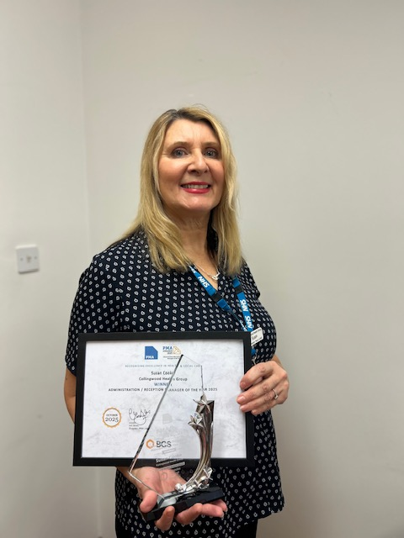  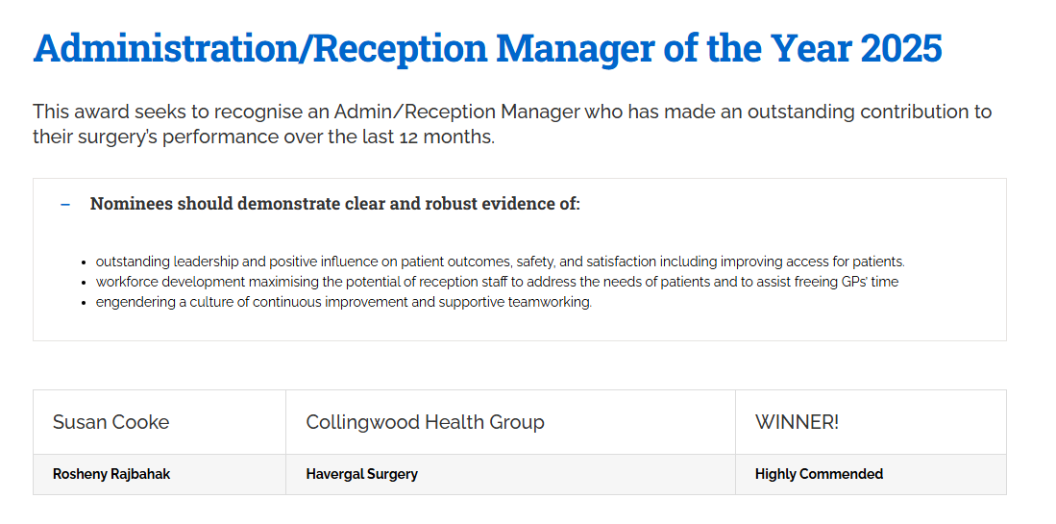
6. |  | Invitation for Your Service Users to Join Northern Cancer Voices Patient & Carer Collaboratives  Patient & Carer Collaboratives – Key Points  - We’re recruiting new members to our Patient & Carer Collaboratives and would appreciate your help spreading the word.  - These collaboratives bring together people with lived cancer experience—patients, carers, and family members—to help shape NHS cancer services.  - Members work with NHS Trusts, the Northern Cancer Alliance, and Public Health teams across the full cancer pathway: screening, prevention, treatment, and aftercare.  Why it matters  - Service users’ real experiences highlight what’s working and where improvements are needed.  - Every six weeks, members join a one-hour online call to:  • Share and discuss experiences  • Identify themes and improvement areas  • Provide feedback directly to NHS partners  • Help shape better cancer services in our region  - It’s an accessible, low-pressure introduction to patient voice and service development.  Collaborative areas  - North of Tyne & Gateshead: Northumberland, North Tyneside, Newcastle, Gateshead  - South Tyneside & Sunderland  Get involved  - Please share this opportunity with anyone who may be interested.  - For more information or to join: message us or email info@northerncancervoices.co.uk.  Thank you for helping strengthen the voice of people affected by cancer.  See posters attached.  PM – Northern cancer voices coordinator and PRG member.  PM arranges getting out to local events to talk about cancer myths and encourage people to attend their regular screening.  The coordinators try to fill in surveys with the attendees to get an idea of their experience dealing with cancer and to provide useful data on how to manage future services.  1 in 2 people get cancer in their lifetime. Assuming they are married or have children then that’s just about everyone that has been touched by cancer.  It is a virtual organisation, no premises, just meet online.  PM is happy to keep us up to date of any future events and will look to get us some posters for walls and media screens.
7. |  | Staffing Changes:  - Branch lead NYS/JPS - Helen Richards since December  - PCN Administrator (based at hub) - June Kelly started Feb  - Workflow administrator – Helen started early Feb  - Health Care Assistant – Tracey started Jan  - Health Care Assistant - Debra starting early March  - General Practice Administrator – Kate – Starting late March  - Dr Ellie Gridley - returning from maternity leave soon  Sadly, practice manager Sandra Dowling has decided to step down from practice management and had resigned from the practice. Her last working day will be Tuesday 31st March.  Newly appointed practice manager Stacey Reid starts Monday 23rd March so will have an overlap with Sandra as a handover period.  Stacey has worked in general practice since age 16. She worked in Wallsend for a period but is currently in Whitburn.
8. |  | Future meetings:  Dr Kathryn Hall is no longer able to commit to attending all meetings due to her increased workload.  Due to the partners having a range of different clinical and personal responsibilities one partner will attend each meeting on a rota basis.  All partners receive the minutes to each meeting so they will all be kept in the loop.
9. |  | Any Other Business:  Lung screening  PR noticed Yorkshire are doing a big push on lung cancer screening and wondering if this will come to North Tyneside.  Cancer Care Co-ordinator Kate has requested the practice ask patients for their smoking history ahead of the Lung Function Team attending one of our business meetings in a few weeks to discuss further.  Bio Bank  As discussed previously this is nothing to do with the surgery. Research Pharmacist Conner was going to investigate but heard nothing.  Biobank were looking to recruit various people to have check ups and follow up over the years. Data is not shared with patient unless there is something terrible.  Sandra discussed re data security so patient engaged biobank to find out how this data is used.  MOTs  Checkups for long term health conditions are usually done in birthday month. There are sometimes a delay due to appointment availability. The Long-term health conditions team will contact anyone due an appointment. The team can be reached on the usual practice number 01912571779 option 5 for any queries relating to these appointments.  NHS Health Checks  If you're aged 40 to 74 and do not have a pre-existing health condition, you should be invited to an NHS Health Check by your GP or local council every 5 years.  The NHS Health Check is a free check-up of the health of your heart and blood vessels (cardiovascular health). It can tell you whether you're at higher risk of getting certain health problem  If you're over 65, you'll also receive information on dementia symptoms and local support services.  Waiting room clock  The clock in the waiting room seems to have vanished. We will look to get one put up asap.
10. |  | Date of Next Meetings:  Wed 20 May 2026 – 2:00–3:30pm  Wed 12 Aug 2026 – 2:00–3:30pm  Wed 18 Nov 2026 – 2:00–3:30pm

